Butte Falls Secondary School Media Syllabus

Ms. Brown 2016-2017

Media Course Description
This class will focus on composition, layout, design concepts, photography, image use, caption writing, copy writing, advertising strategies, and marketing. Students should feel connected to the school community and be ready to work with peers, teachers and administration to gather media/information. This course will assist students in becoming better communicators, better readers, writers, speakers, and listeners. Students will be required to complete assignments that may be posted in the Butte Falls Charter School Yearbook, the Butte Falls Community Bulletin, The Butte Falls Charter School Website, The Butte Falls Charter School Facebook page, the Reader Board, Bulletin Boards throughout the school, etc.

Required Materials
Signed Computer Use/Internet Form
Pencils/Pens
Notebook paper

Recommended Materials
USB Flash Drive
Headphones

What are my expectations of you?
- Complete assignments on time
- Participate
- Ask for help, when needed
- Come to class prepared and ready to learn
- Make up all work when you are absent
- Do your own work
- Students will be required to attend THREE extra-curricular events per grading period. Students will be required to provide their own transportation to these events to take photographs. Attendance at these activities/events are part of each student’s grade for the class and assignments will be based on event attendance.
Cheating, plagiarism, and other acts of academic dishonesty are regarded as serious offenses. While you may work/consult with classmates, any work you turn in must be your own. Depending on the nature of the offense, serious penalties may be imposed, ranging from receiving a zero on the assignment to failure of the class.

Classroom Rules
1. No Personal Electronic Devices Allowed – this includes cell phones, IPods, mp3 players, etc. Exceptions may be made for purposes of transferring pictures/media to classroom computers.
2. Be Respectful – treat all students, staff, and property with care and kindness.
3. Be Attentive – pay attention, be alert, cooperate with teacher/classmates, and stay engaged.
4. Be Prepared for Class – bring all required materials to class, be in your seat ready to learn when the bell rings, take care of personal business during lunch/passing time.
5. No food or Drinks allowed in Computer Lab. Gum is ok until you abuse that privilege.

Consequences
- Warning and/or conference after class
- Sent out of class to hallway to complete reflection.
- Office referral (administrative decision on consequence)
Severe rule breaking may result in immediate jump to step 2/3 on the consequences above.
Grading Policy

Classwork/Projects
Classwork/Projects 95% will vary between 10 and 100 points each depending on time required to complete and effort required. Each day you will be working on independent projects from the various programs/activities we are covering. There will be approximately 1-2 weeks of class time provided to complete each project. Unless otherwise stated all assignments will be due at the end of class on the Thursday after it was assigned. If you are absent on Thursday your homework must be turned in at the beginning of class on Monday, no exceptions. Unexcused absences may result in assignments not be accepted. If you have a computer at home and save your projects on a USB/Google drive you may also work on projects at home, but note that you will need to have the required program on your computer at home.

Personal Management
You will be required to attend class, participate, and keep your materials organized for a Personal Management 5% grade. You will be using a computer almost every day in this class. You are expected to use them responsibly. Misuse of any school equipment will not be tolerated and you will be held responsible for any damage that you cause. Internet/computer use is a privilege. Use a little bit of common sense – if you think it’s wrong, it probably is.

Late work will be accepted with 10% penalty per week up to 3 weeks. 1 week late max score 90%, 2 weeks late max score 80%, 3 or more weeks late max score 70%.

Semester Grade will be issued based on the following percentage scale:
A = 90 to 100% of total points
B = 80 to 89 % of total points
C = 70 to 79 % of total points
D = 60 to 69% of total points
F= 59% and below of total points

Contact Information
- Send an email: sbrown@buttefalls.k12.or.us. I check it several times per day. I also check my email regularly afterschool and on the weekends/breaks.
- Call me at school. Please leave a message and I’ll get back to you during my planning period or after school. My number is 865-3563 ext. 257

Email/Text Notifications
Information, updates, and important reminders about assignments, upcoming deadlines, class activities, permission slips and other paperwork will be sent using Remind. You can receive these updates by text message, email, or both by following the instructions below.
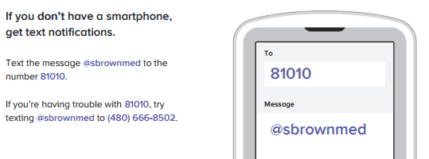
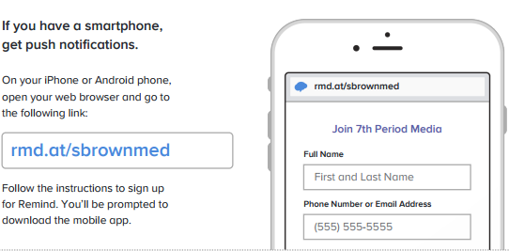
Please return this page by Thursday, September 8th.

____ I have read the attached Media Syllabus.

____I signed up for Email/Text Notifications

____________________ ____________________ ________
Student’s Printed Name Student’s Signature Date

____________________ ____________________ ________
Guardian’s Printed Name Guardian’s Signature Date

Parent/Guardian’s Contact Information________________________________________

Best person to contact _________________________________________________________

Address_____________________________________________________________________

Home/Cell Phone _________________________Work Phone _________________________

Home E-mail ____________________________Work E-mail _________________________

I prefer to be contacted by: ___Phone ___Email

Best time to be reached by phone is: ______________________________________________

Comments/Concerns:
____________________________________________________________________________________________________________________________________________________________________________________________________________________________________________________________________________________________________________________________________________________________________________________________________________________________________________________________________________________________________________________________________________________________________________________________________________________________________________________________________________________________________________________________________________________________________________________________________________________________________________________________________________________________________________________________________
____________________________________________________________________________________________________________________________________________________________________________________
__________________________________________________________________________________________

